Quality Management System
(QMS)

MODULE 1:Document Change Request(DCR)

Project Overview
The Quality Management System (QMS) – ISO Document Control System is a web-based application designed to automate the manual process of ISO document submission, review, approval, and revision management in an organization.
The system allows employees to submit Document Change Requests (DCRs), which are reviewed by the Department Head and Quality Manager. Once approved, the DCR Head finalizes the document as a PDF, stores it in the appropriate department's shared ISO folder, and updates the Master Document Register with the latest revision details.
The application is developed using Angular for the frontend, ASP.NET Core Web API for the backend, and SQL Server for database management. It provides role-based access, approval tracking, document revision history, centralized file access, and audit logging.
The main objective is to reduce manual work, improve document traceability, maintain revision accuracy, and ensure that authorized users can access the latest approved ISO documents.

System Architecture
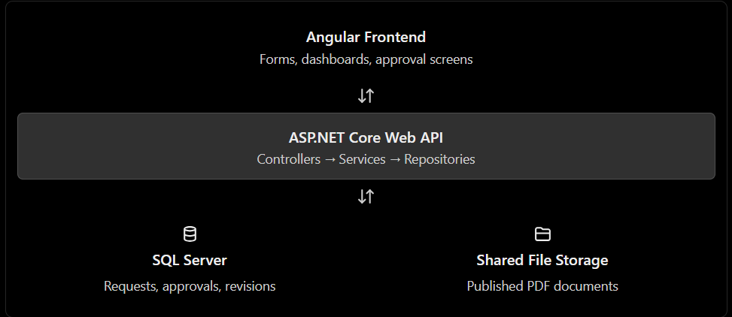

Database Architecture

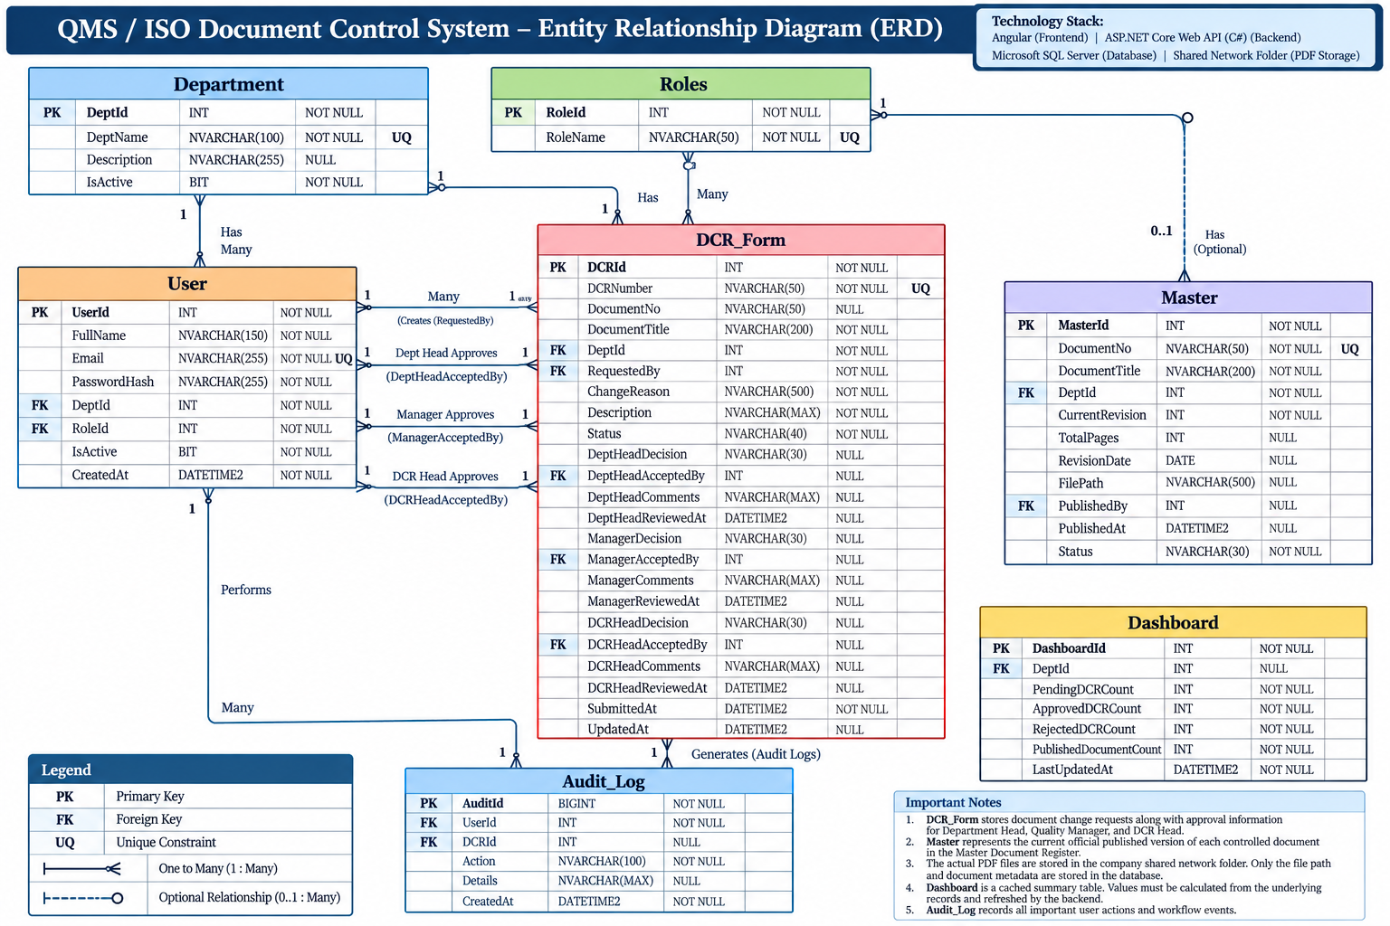

Description of each table:

1. Department Table
Stores the list of departments in the organization, such as Production, Quality, HR, and Maintenance. It helps associate users and controlled documents with their respective departments.

2. Roles Table
Stores the roles available in the system, such as Employee, Department Head, Quality Manager, DCR Head, and Admin. It supports role-based access control.

3. User Table
Stores employee account information, including login credentials, department assignment, and role. It identifies the employees who submit DCRs and the users responsible for reviewing and approving them.

4. DCR_Form Table
Stores Document Change Requests, including document details, reasons for changes, workflow status, and approval decisions from the Department Head, Quality Manager, and DCR Head. It tracks the request throughout the review and approval process.

5. Master Table
Maintains the Master Document Register containing the latest officially published ISO documents. It stores document details, current revision, page count, revision date, and the file path of the approved PDF in the shared ISO folder.

6. Audit_Log Table
Maintains a record of important system activities, including DCR submissions, approvals, rejections, correction requests, and document publications. It supports traceability and auditing by recording who performed an action and when.

7. Dashboard Table
Stores precomputed summary statistics used to display information such as pending DCRs, approved and rejected requests, and published documents. This table is optional because the dashboard statistics can also be calculated directly from the DCR_Form and Master tables.

Complete End to End Flow

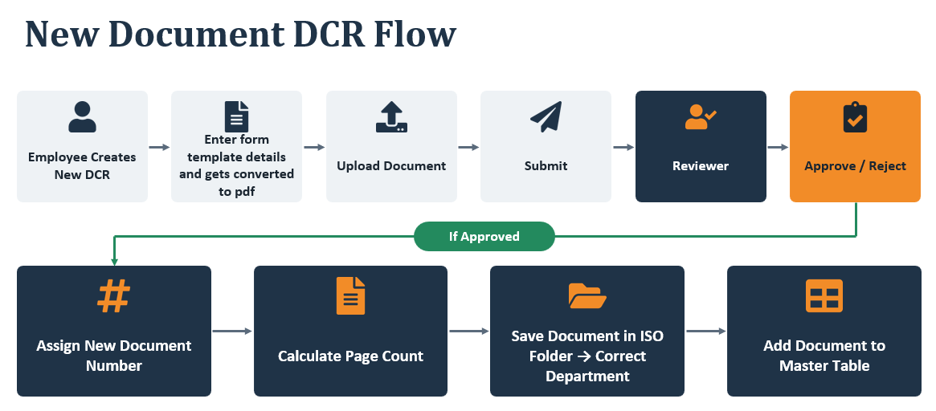
Login Screen

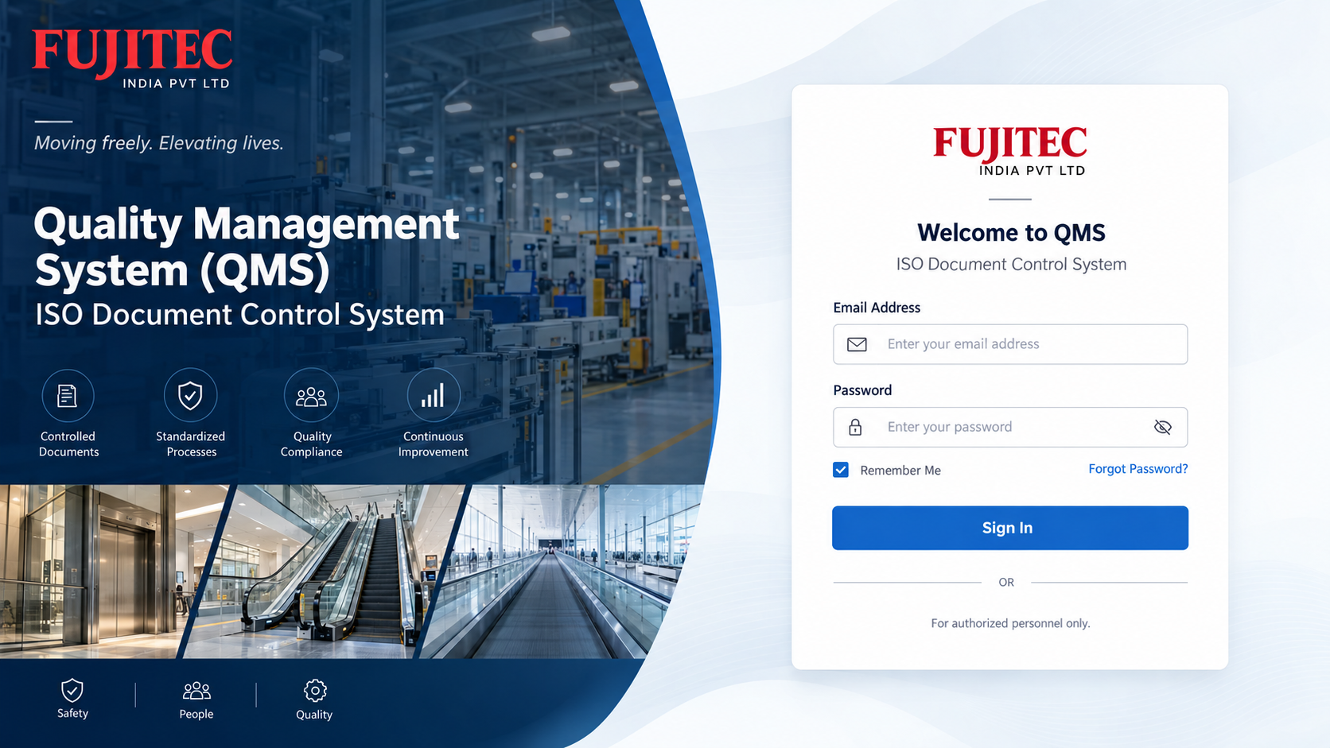

DCR Screen

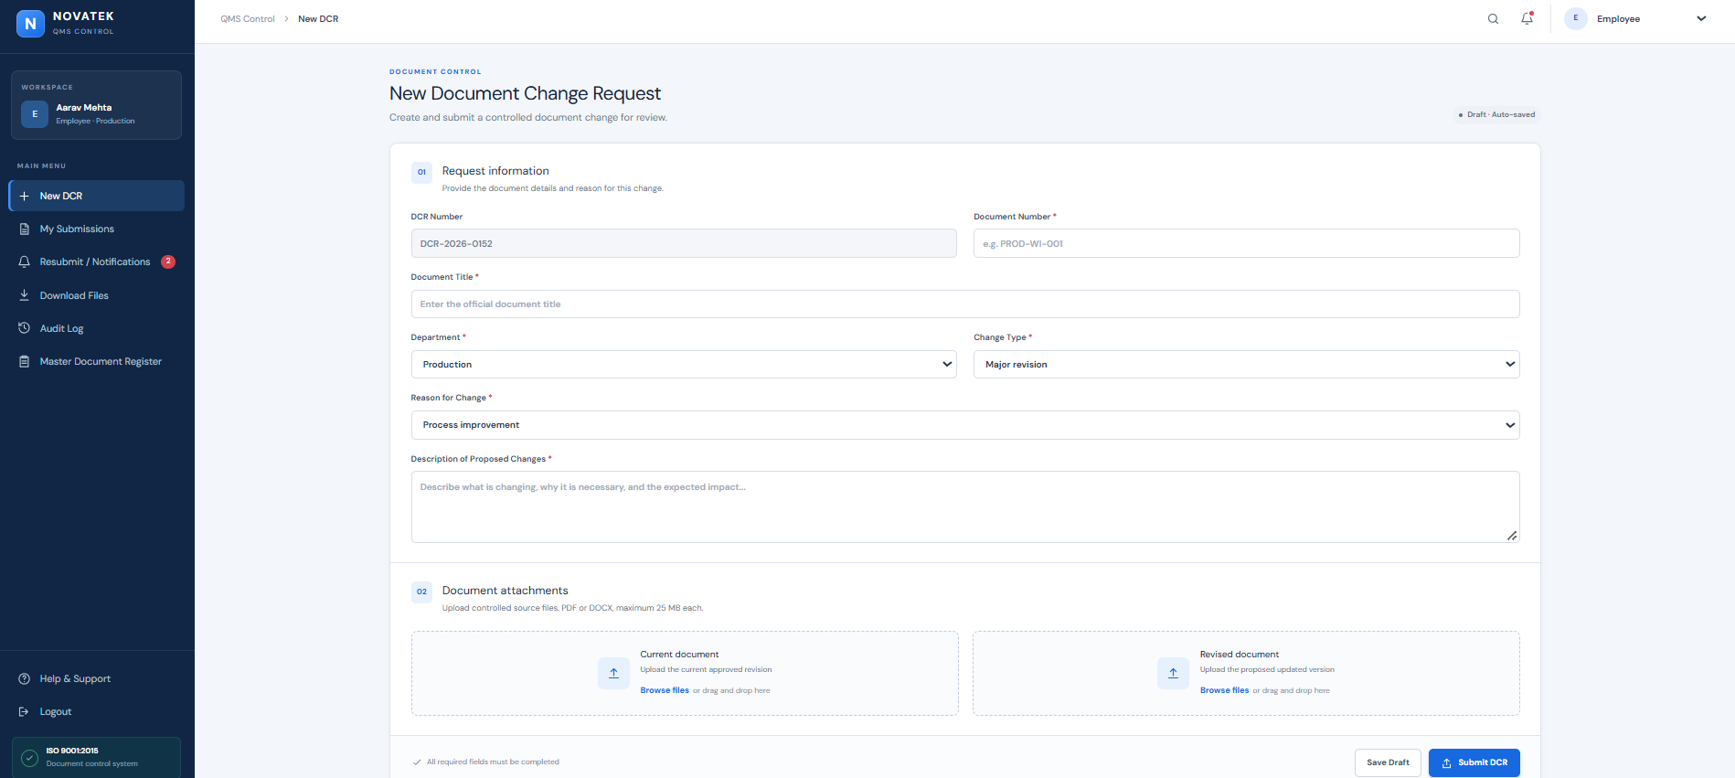

My Submission Screen

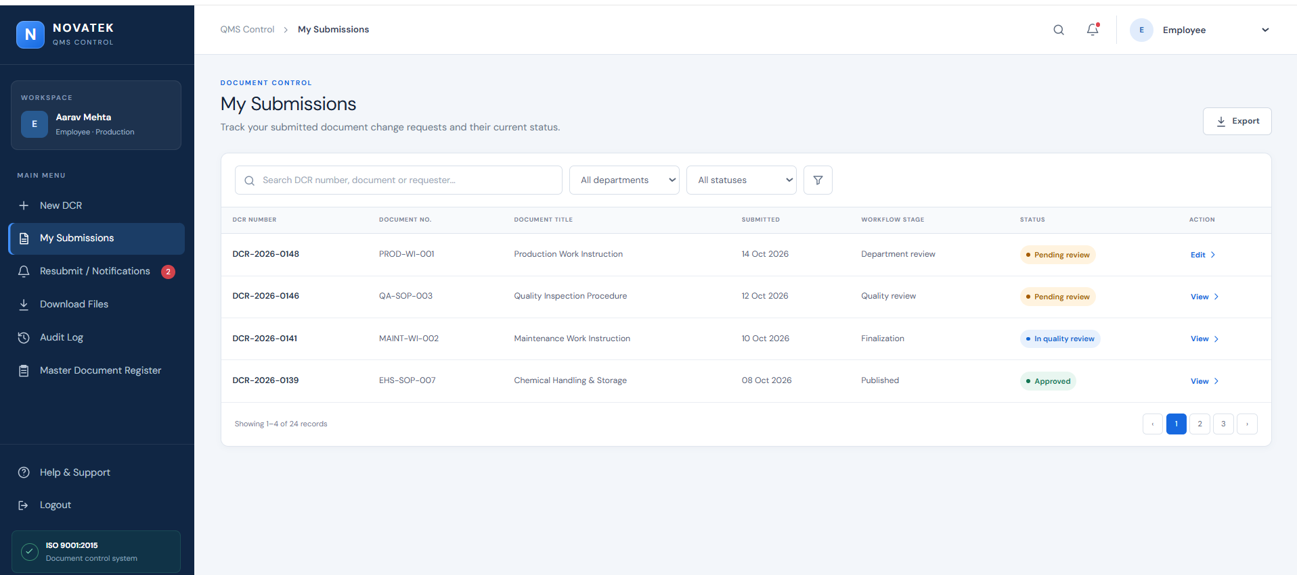

Resubmit Screen/Notifications Screen
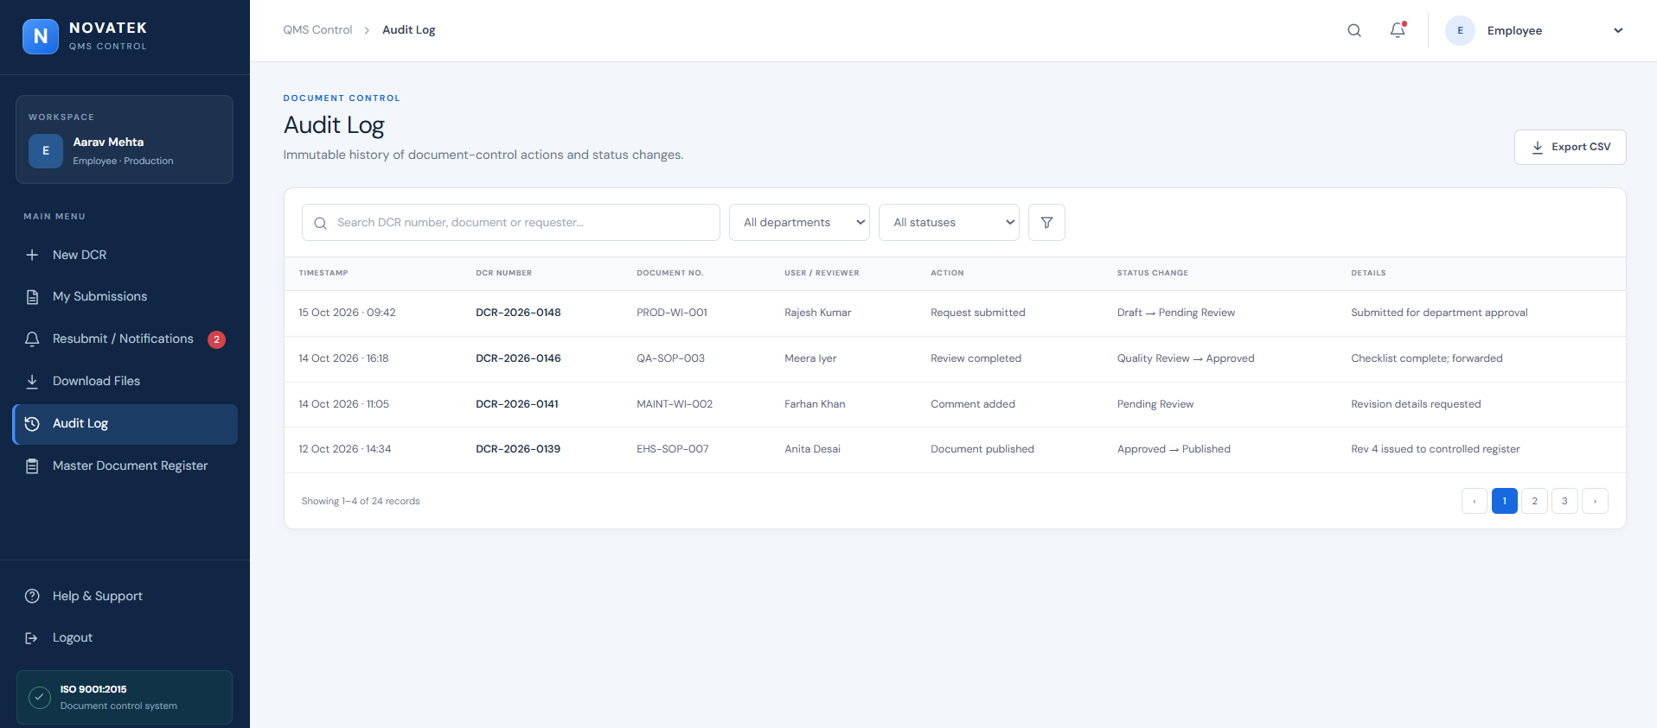

Master Table Screen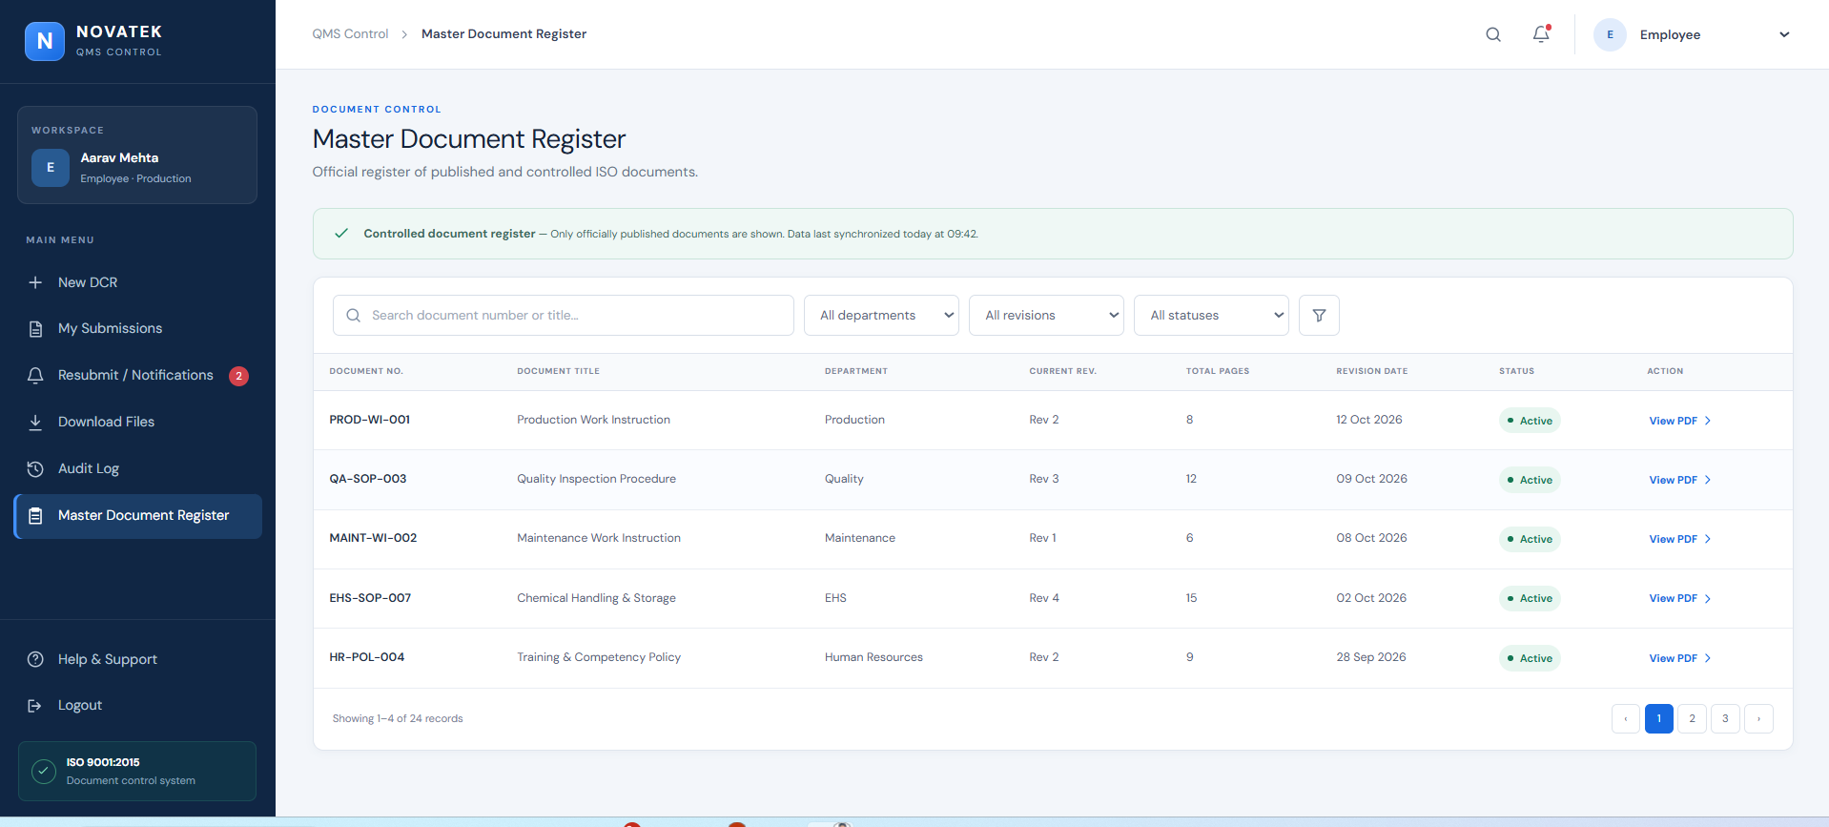

DashBoard Screen
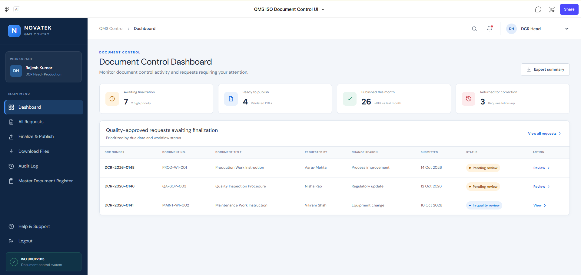

Download Files Screen
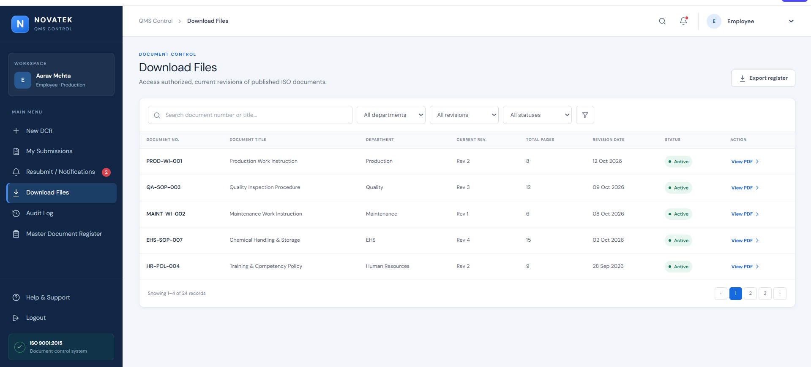

Audit Log Screen:

The same screens gets repeated base upon the user roles(like employee,Dept Head,Quality Manager,DCR Head)

